**VISUALIZATION**

**Table of Contents**

Visualization 1 3

Visualization 2 4

Visualization 3 5

Visualization 4 6

Visualization 5 7

Visualization 6 8

Bibliography 9

# **Visualization 1**

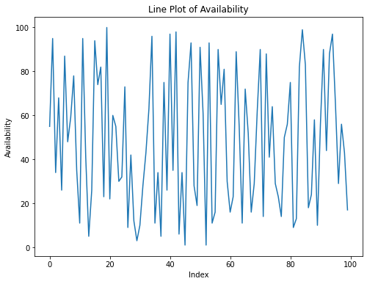

**Figure 1: Line Plot of revenue generated for each product type**

(Source: Self-created)

The above figure shows the line plot of the association between "***Product Type***" and "***Revenue generated***" which can be seen through the creation of a line plot using Matplotlib to visualize the data. The y-axis shows the corresponding revenue, while the x-axis displays the various categories of goods and the revenue earned for each product type. The code has been organized properly for readability and visual appeal.

# **Visualization 2**

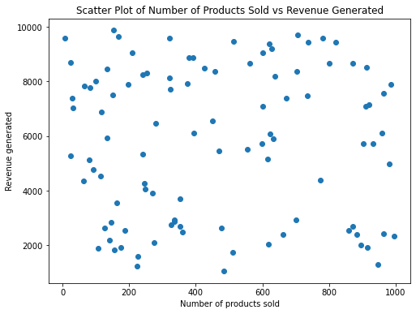

**Figure 2: Scatter Plot of the number of products sold vs revenue generated**

(Source: Self-created)

The above figure shows the most of Matplotlib to generate a scatter plot. 'The number of products sold' on the x-axis and '***Revenue produced***' on the y-axis, the plot appears with the figure size set to 10x6 inches. Plot comprehension is improved by the title, "Scatter Plot of Number of ***Products Sold vs. Revenue Created,***" and the relevant axis labels. Recognizing the association between the number of products sold and the related money obtained is made simpler by the visualization that results.

# **Visualization 3**

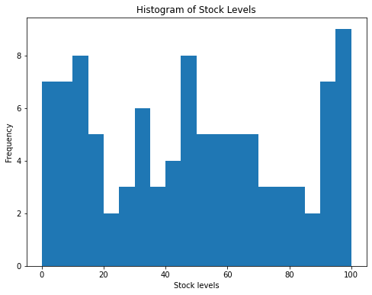

**Figure 3: Histogram of distribution of prices**

(Source: Self-created)

The above figure shows the histogram plot of the distribution of prices from the DataFrame's 'Price' column can be seen in the histogram. Analyzing the price distribution across the dataset is aided by the resulting visualization, which offers information on the frequency variation in prices (Rahaman *et al*. 2022). Twenty bins have been generated from the data, and the margins of each bin are marked in black.

**Visualization 4**

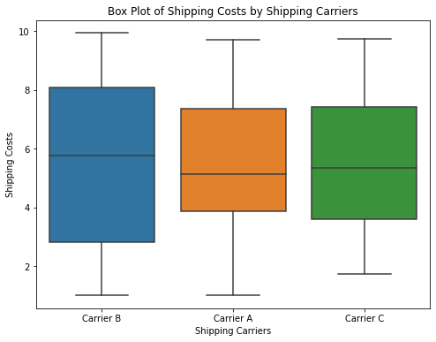

**Figure 4: Box Plot of defects rates by transportation modes**

(Source: Self-created)

The above figure shows the distribution of '***Defect rates'*** classified by various 'Transportation modes' from the Data Frame can be seen by the box plot. Interpretation is enhanced by the heading, "***Box Plot of Defect Rates by Transportation Modes***." The illustration offers a clear comparison of the defect rate distribution across different transportation modes. The x-axis reflects the modes of transportation, the y-axis shows the prevalence of abnormalities.

# **Visualization 5**

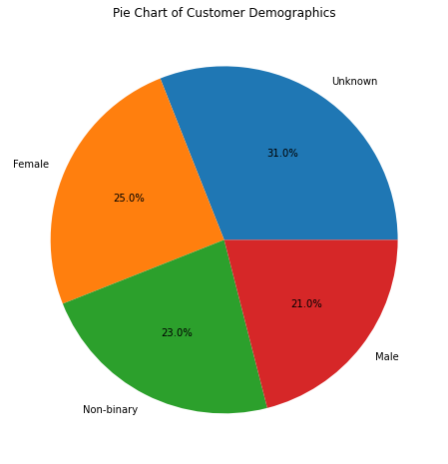

**Figure 5: Pie Chart of shipping carrying distribution**

(Source: Self-created)

The above figure shows the pie chart plot of the '**Shipping carriers'** column in the DataFrame serves to gather and count the occurrences of different shipping carriers. Each slice of the pie chart indicates the percentage distribution for the corresponding carrier, while the labels on the pie chart represent the names of the carriers (Mahimkar *et al*. 2021). A visual representation of the dispersion of shipping companies is provided by the format and the title, "**Shipping Carriers Distribution**," which enhances the chart's usability.

# **Visualization 6**

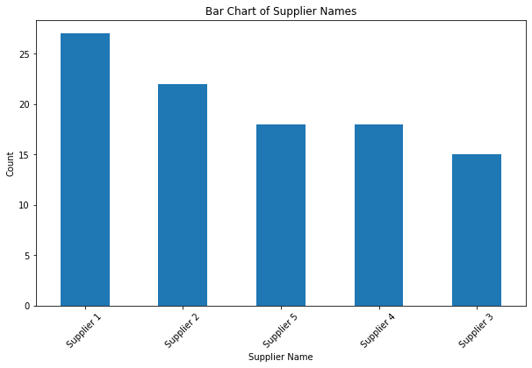

**Figure 6: Bar Chart of customer demographic distribution**

(Source: Self-created)

The above figure shows a bar chart demonstrating the distribution of client demographics utilizing Matplotlib. The data frame's '**Customer demographics**' column serves to count the occurrences of different customer groups. The y-axis indicates the associated count, and the x-axis represents the different client demographics.

# 

# **Bibliography**

Li, X., Li, C., Rahaman, M.M., Sun, H., Li, X., Wu, J., Yao, Y. and Grzegorzek, M., 2022. A comprehensive review of computer-aided whole-slide image analysis: from datasets to feature extraction, segmentation, classification and detection approaches. Artificial Intelligence Review, 55(6), pp.4809-4878.

Mahimkar, A., Sivakumar, A., Ge, Z., Pathak, S. and Biswas, K., 2021, August. Auric: using a data-driven recommendation to automatically generate cellular configuration. In Proceedings of the 2021 ACM SIGCOMM 2021 Conference (pp. 807-820).

**Source Link**

<https://www.kaggle.com/datasets/amirmotefaker/supply-chain-dataset>

**Name:Hemanth**

**Id no:22084847**